Waterfall

**Extro Angular Bib Cock – Single Lever Handle**

**Product Description:**  
Stylish wall-mounted bib cock designed for efficient water control, featuring a modern single-lever handle and durable chrome finish, perfect for bathroom and utility installations.

**Key Features:**  
✅ Compact angular body with smooth water flow  
✅ Ergonomic single lever for easy operation  
✅ Chrome-plated brass construction for durability  
✅ Wall flange included for clean finish  
✅ Ideal for basin, garden, or bathroom use

**Product Specifications:**  
• **Brand:** Extro  
• **Product Type:** Bib Cock  
• **Mounting Type:** Wall Mounted  
• **Handle Type:** Single Lever  
• **Material:** High-Quality Brass  
• **Finish:** Chrome Plated (CP)  
• **Inlet Connection:** 15mm BSP  
• **Flow Type:** Stream Flow  
• **Cartridge:** Quarter Turn Ceramic Disc  
• **Application:** Bathroom, Utility Area, Outdoor Tap  
• **Warranty:** 5 Years Manufacturer Warranty

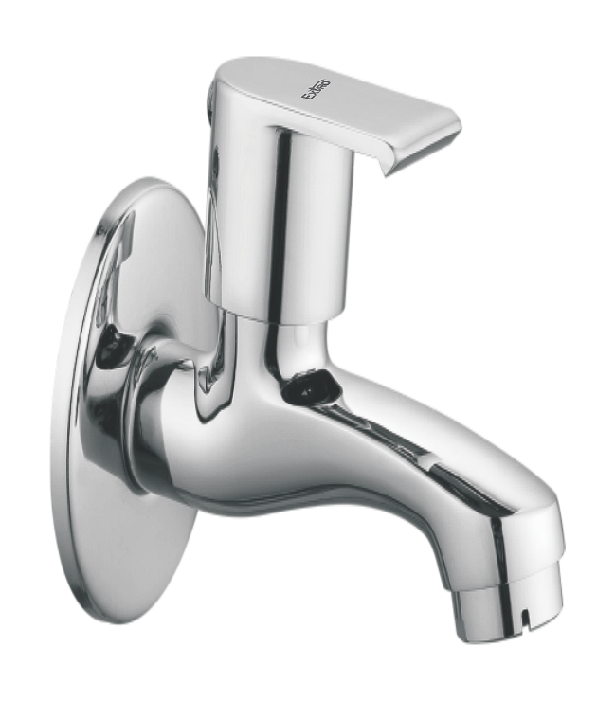

**Extro Long Body Bib Cock – Single Lever Handle**

**Product Description:**  
Elegant and durable long body bib cock from Extro, designed for smooth water flow with a stylish single lever, perfect for use in bathrooms and utility areas.

**Key Features:**  
✅ Extended body for better reach and usability  
✅ Sleek chrome finish with modern single lever design  
✅ High-grade brass ensures corrosion resistance  
✅ Wall-mounted with cover flange for neat installation  
✅ Smooth quarter-turn operation with ceramic cartridge

**Product Specifications:**  
• **Brand:** Extro  
• **Product Type:** Long Body Bib Cock  
• **Mounting Type:** Wall Mounted  
• **Handle Type:** Single Lever  
• **Material:** Brass  
• **Finish:** Chrome Plated (CP)  
• **Inlet Connection:** 15mm BSP  
• **Operation Type:** Quarter Turn Ceramic Cartridge  
• **Flow Type:** Stream  
• **Application:** Bathroom, Kitchen, Utility  
• **Warranty:** 5 Years Manufacturer Warranty

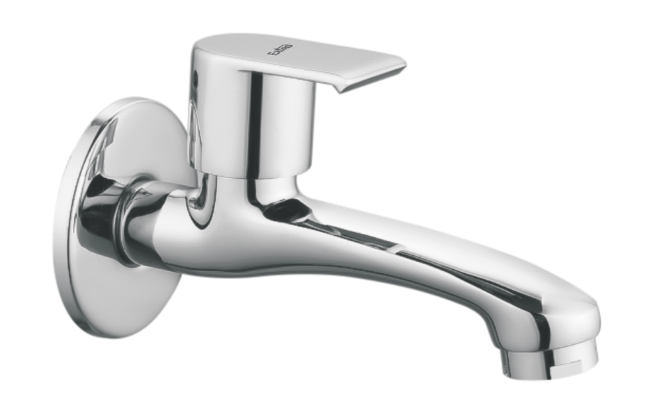

**Extro Angular Stop Cock with Wall Flange – Single Lever**

**Product Description:**  
Modern angular stop cock from Extro with a single lever for efficient flow control, ideal for geysers, washing machines, or concealed water connections.

**Key Features:**  
✅ Sleek and compact angular design for space-saving installation  
✅ Easy quarter-turn operation with ergonomic lever handle  
✅ Brass body with chrome finish for long-lasting performance  
✅ Wall flange included for seamless wall fitting  
✅ Standard threaded outlet compatible with most connections

**Product Specifications:**  
• **Brand:** Extro  
• **Product Type:** Angular Stop Cock  
• **Mounting Type:** Wall Mounted  
• **Handle Type:** Single Lever  
• **Material:** Brass  
• **Finish:** Chrome Plated (CP)  
• **Inlet Connection:** 15mm BSP  
• **Outlet:** Threaded Male (suitable for appliances/pipes)  
• **Operation Type:** Quarter Turn Ceramic Disc  
• **Application:** Geyser, Washing Machine, Basin, etc.  
• **Warranty:** 5 Years Manufacturer Warranty

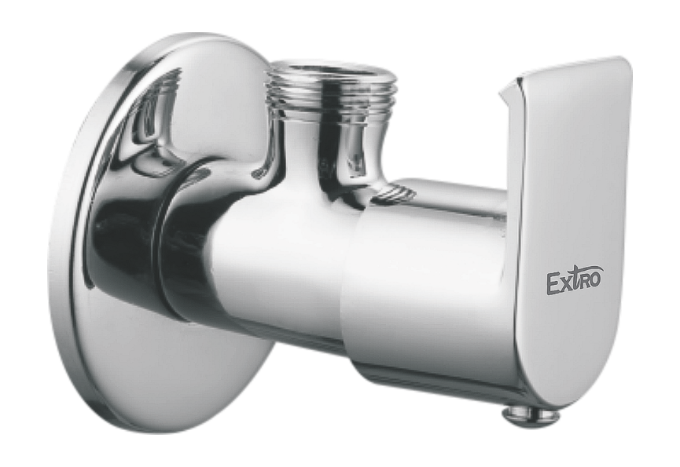

**Extro Concealed Stop Cock – Single Lever**

**Product Description:**  
Extro’s premium concealed stop cock with single lever control and robust brass body ensures smooth water regulation in bathrooms, kitchens, or utility spaces.

**Key Features:**  
✅ Elegant concealed design for a modern aesthetic  
✅ Single lever control for effortless water flow adjustment  
✅ Heavy-duty forged brass body for durability  
✅ Chrome-plated top for corrosion resistance  
✅ Ideal for both hot and cold water pipelines

**Product Specifications:**  
• **Brand:** Extro  
• **Product Type:** Concealed Stop Cock  
• **Material:** Brass Body with Chrome-Plated Lever  
• **Mounting Type:** Concealed (in-wall)  
• **Operation Type:** Single Lever, Quarter Turn  
• **Inlet/Outlet Connection:** 15mm BSP Threaded  
• **Finish:** Matte Brass with Chrome Handle  
• **Application:** Bathroom/Kitchen Pipeline Flow Control  
• **Warranty:** 5 Years Manufacturer Warranty

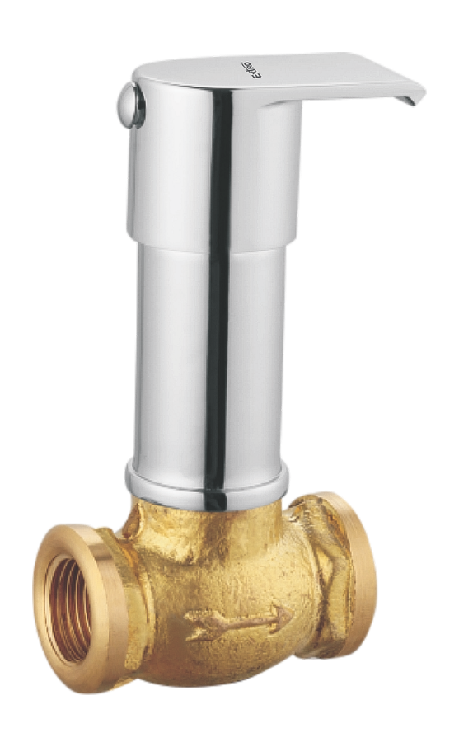

**Extro Pillar Tap – Single Lever Basin Mixer**

**Product Description:**  
Extro’s stylish pillar tap with single lever operation delivers smooth and controlled water flow, perfect for modern wash basins and counters.

**Key Features:**  
✅ Sleek cylindrical body with premium chrome finish  
✅ Single lever operation for precise flow and temperature control  
✅ Corrosion-resistant brass body for long life  
✅ Foam flow aerator for water efficiency  
✅ Easy deck-mounted installation for all basins

**Product Specifications:**  
• **Brand:** Extro  
• **Product Type:** Pillar Tap / Basin Mixer  
• **Material:** Brass with Chrome Plating  
• **Mounting Type:** Deck Mounted  
• **Handle Type:** Single Lever  
• **Finish:** Mirror Chrome  
• **Operation:** Quarter Turn Ceramic Disc Cartridge  
• **Flow Type:** Foam Flow with Aerator  
• **Application:** Bathroom/Wash Basin  
• **Warranty:** 5 Years Manufacturer Warranty

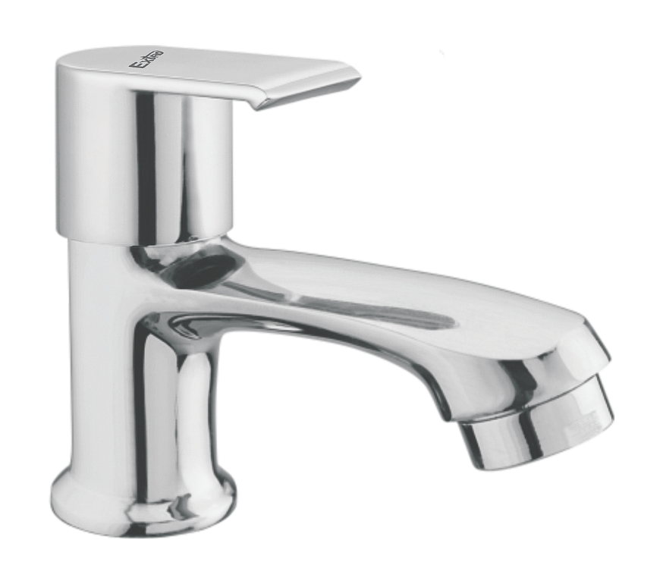

**Extro Wall Mixer Non-Telephonic – Single Lever**

**Product Description:**  
Extro’s elegant wall mixer with single lever offers a compact solution for water mixing and outlet control, ideal for bathroom use without shower provision.

**Key Features:**  
✅ Single lever control for effortless flow and mix  
✅ Compact body with smooth chrome finish  
✅ Non-telephonic design ideal for basin/bucket use  
✅ Durable brass body ensures longevity  
✅ Compatible with overhead tanks and pressure pumps

**Product Specifications:**  
• **Brand:** Extro  
• **Product Type:** Wall Mixer (Non-Telephonic)  
• **Material:** Solid Brass with Chrome Finish  
• **Handle Type:** Single Lever  
• **Mounting Type:** Wall Mounted  
• **Finish:** Mirror Chrome Plating  
• **Outlet Type:** Downward Outlet Only (No Overhead)  
• **Cartridge Type:** Ceramic Disc Cartridge  
• **Application:** Bathroom Wall Mixer (without shower diverter)  
• **Warranty:** 5Years Manufacturer Warranty

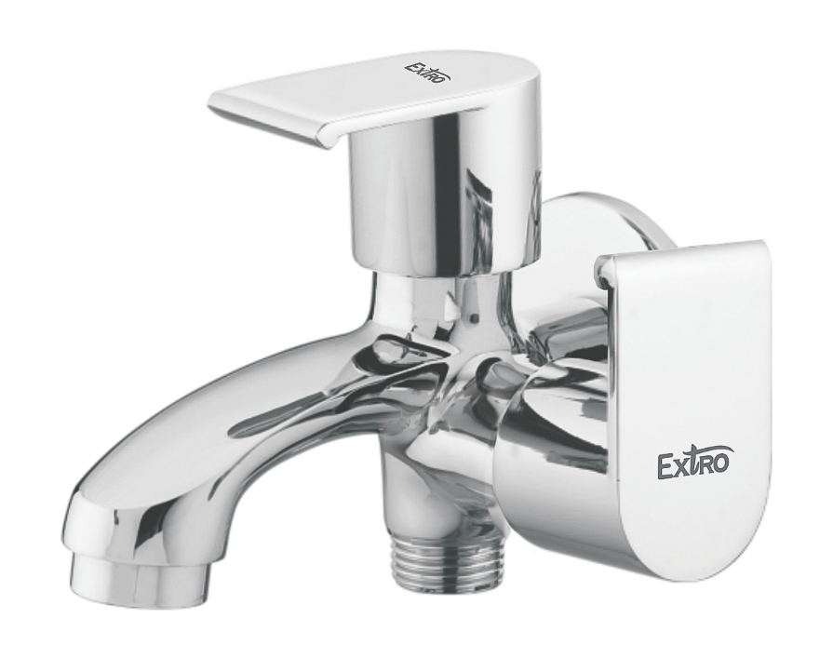

**Extro Two-Way Angle Valve with Wall Flange – Single Lever**

**Product Description:**  
Extro’s sleek and sturdy two-way angle valve is ideal for managing dual water flow outlets from a single wall-mounted fixture with precision and durability.

**Key Features:**  
✅ Dual outlet control for geyser and hand shower  
✅ Single lever operation with effortless switching  
✅ Premium chrome finish with corrosion resistance  
✅ Durable brass body construction  
✅ Compact design for modern bathrooms

**Product Specifications:**  
• **Brand:** Extro  
• **Product Type:** 2-Way Angle Valve with Wall Flange  
• **Material:** Solid Brass  
• **Finish:** Chrome Plated  
• **Control:** Single Lever for 2-Way Flow  
• **Mounting Type:** Wall Mounted  
• **Inlet Connection Size:** Standard 15mm (½”) BSP  
• **Outlet:** Dual (Hand Shower & Geyser/Faucet)  
• **Cartridge Type:** Ceramic Disc Cartridge  
• **Application:** Bathroom water supply control  
• **Warranty:** 5 Years Manufacturer Warranty

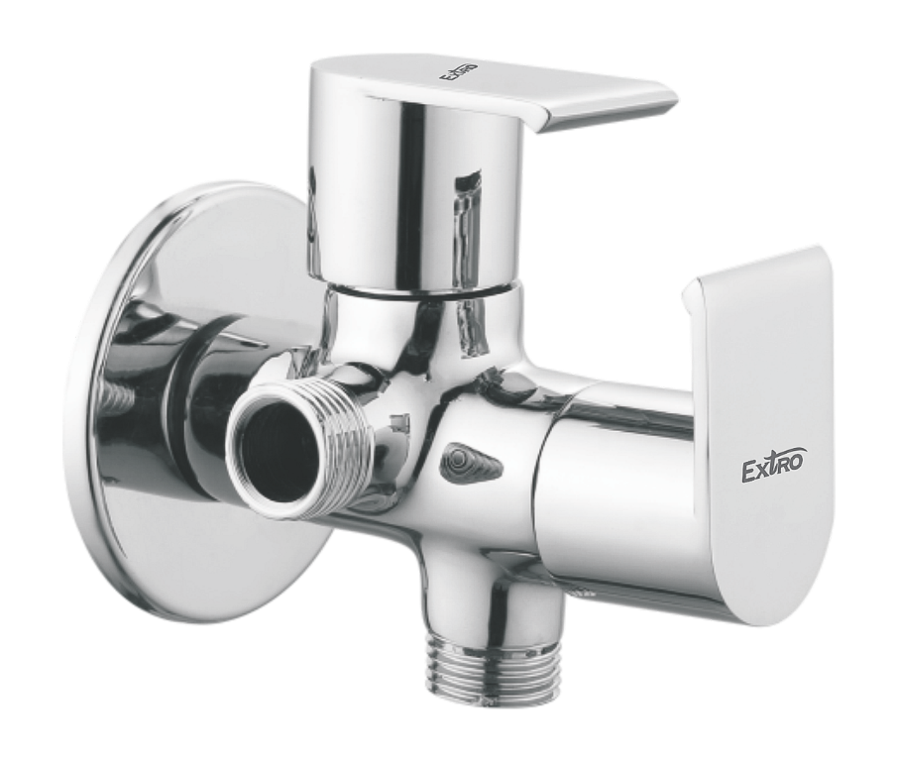

**Extro Wall Mounted Sink Tap with Swivel Spout**

**Product Description:**  
The Extro wall-mounted sink tap with high-arc swivel spout is engineered for smooth water flow and effortless directional control, ideal for kitchens or utility sinks.

**Key Features:**  
✅ 360° swivel spout for maximum sink coverage  
✅ Wall mounted design for space efficiency  
✅ Chrome-plated brass body ensures corrosion resistance  
✅ Single lever handle for smooth flow control  
✅ Aerator provides splash-free water stream

**Product Specifications:**  
• **Brand:** Extro  
• **Product Type:** Sink Tap – Wall Mounted  
• **Material:** Brass Body  
• **Finish:** Chrome Plated  
• **Spout Type:** 360° Rotating Swivel Spout  
• **Mounting Type:** Wall Mount  
• **Handle Type:** Single Lever  
• **Connection Size:** 15mm (½”) BSP  
• **Application:** Kitchen/Utility Sink  
• **Flow Control:** Smooth and Adjustable  
• **Warranty:** 5 Years Manufacturer Warranty

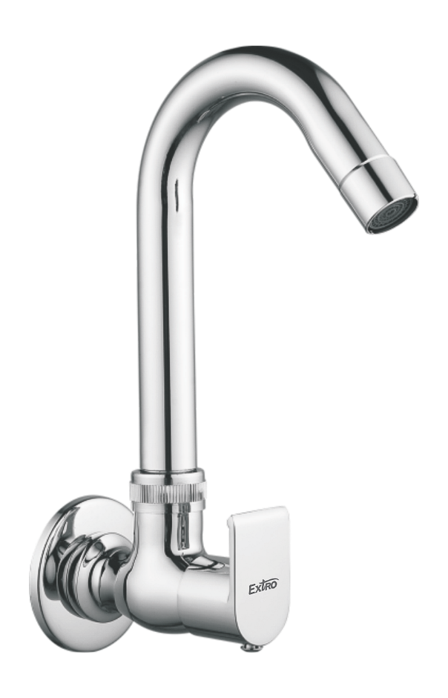

**Extro Table Mounted Sink Tap with Swivel Spout**

**Product Description:**  
This Extro table-mounted sink tap features a sleek, tall design with a 360° swivel spout for convenience and modern utility—perfect for kitchen or utility sinks.

**Key Features:**  
✅ 360° swivel spout for enhanced reach and flexibility  
✅ Chrome-plated brass body for long-lasting durability  
✅ Table-mount installation for compact sink spaces  
✅ Single lever for easy water flow and temperature control  
✅ Aerator ensures smooth and splash-free flow

**Product Specifications:**  
• **Brand:** Extro  
• **Product Type:** Table Mounted Sink Tap  
• **Material:** Brass  
• **Finish:** Chrome Plated  
• **Mounting Type:** Table Top  
• **Spout Type:** High-Rise Swivel Spout (360° Rotation)  
• **Handle Type:** Single Lever  
• **Connection Size:** 15mm (½”) BSP  
• **Application:** Kitchen/Utility Sink  
• **Flow Control:** Smooth Aerated Flow  
• **Warranty:** 5 Years Manufacturer Warranty

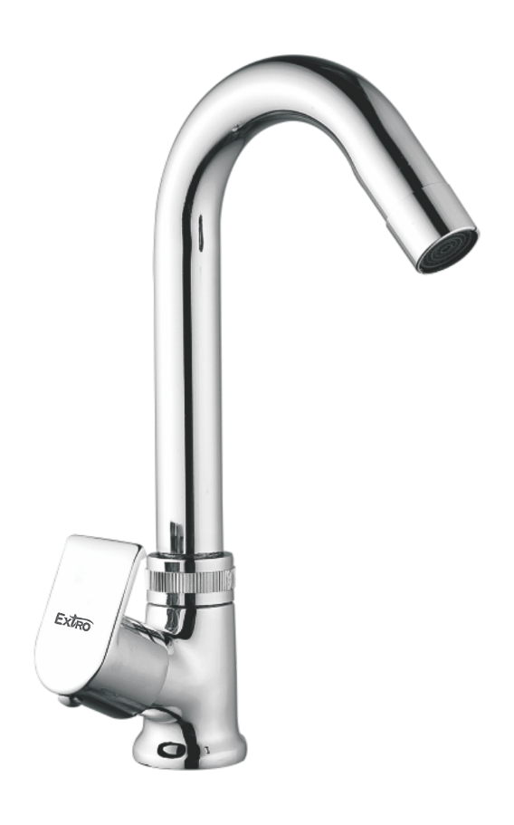

**Extro Wall Mounted Sink Mixer with Swivel Spout**

**Product Description:**  
This Extro wall-mounted sink mixer combines dual-handle precision with a 360° swivel spout, ideal for kitchen or utility sinks that require hot and cold water control.

**Key Features:**  
✅ Dual-handle operation for hot and cold water control  
✅ Chrome-plated brass construction for durability and shine  
✅ 360° swivel spout for maximum sink coverage  
✅ Wall-mounted design saves counter space  
✅ Aerator for smooth, splash-free water flow

**Product Specifications:**  
• **Brand:** Extro  
• **Product Type:** Wall Mounted Sink Mixer  
• **Material:** Brass  
• **Finish:** Chrome Plated  
• **Mounting Type:** Wall Mount  
• **Spout Type:** High-Rise Swivel Spout (360° Rotation)  
• **Handle Type:** Dual Lever  
• **Inlet Connection:** 15mm (½”) BSP  
• **Water Flow:** Mixed Hot and Cold  
• **Application:** Kitchen/Utility Sink  
• **Warranty:** 5 Years Manufacturer Warranty

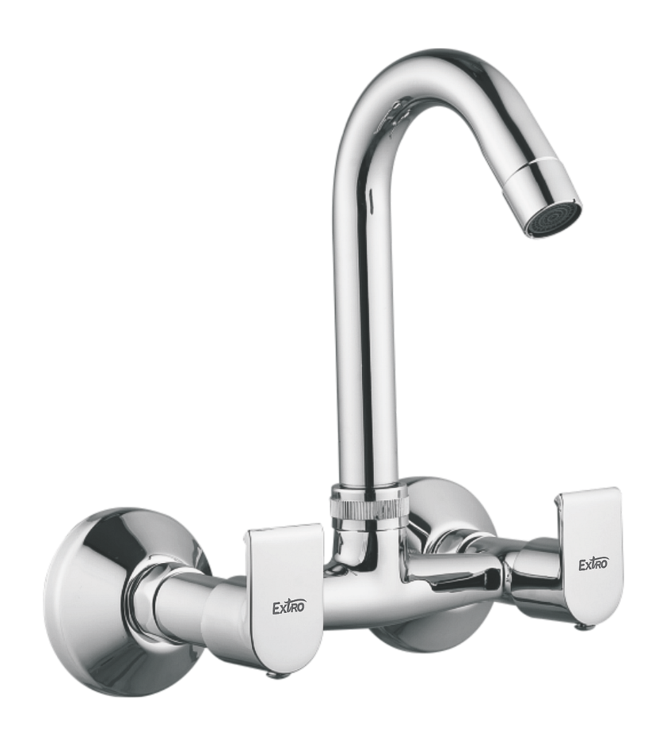

**Extro Pillar Cock with Swinging Spout – Dual Handle**

**Product Description:**  
A premium-quality dual-handle pillar cock with a high-rise swinging spout, designed for modern kitchens or basins requiring hot and cold water control from a single unit.

**Key Features:**  
✅ Dual-handle design for precise hot and cold water control  
✅ Elegant U-shaped rotating spout for wider sink coverage  
✅ Premium brass construction with chrome-plated finish  
✅ Smooth lever handles with ergonomic grip  
✅ Easy countertop installation for modern settings

**Product Specifications:**  
• **Brand:** Extro  
• **Product Type:** Pillar Cock with Swinging Spout (Dual Handle)  
• **Material:** Brass  
• **Finish:** Chrome Plated  
• **Mounting Type:** Deck Mounted  
• **Spout Type:** High-Rise Swivel Spout (360° Rotation)  
• **Handle Type:** Dual Lever  
• **Inlet Connection:** 15mm (½”) BSP  
• **Water Flow:** Mixed Hot and Cold  
• **Application:** Kitchen Sink / Countertop Basin  
• **Warranty:** 5 Years Manufacturer Warranty

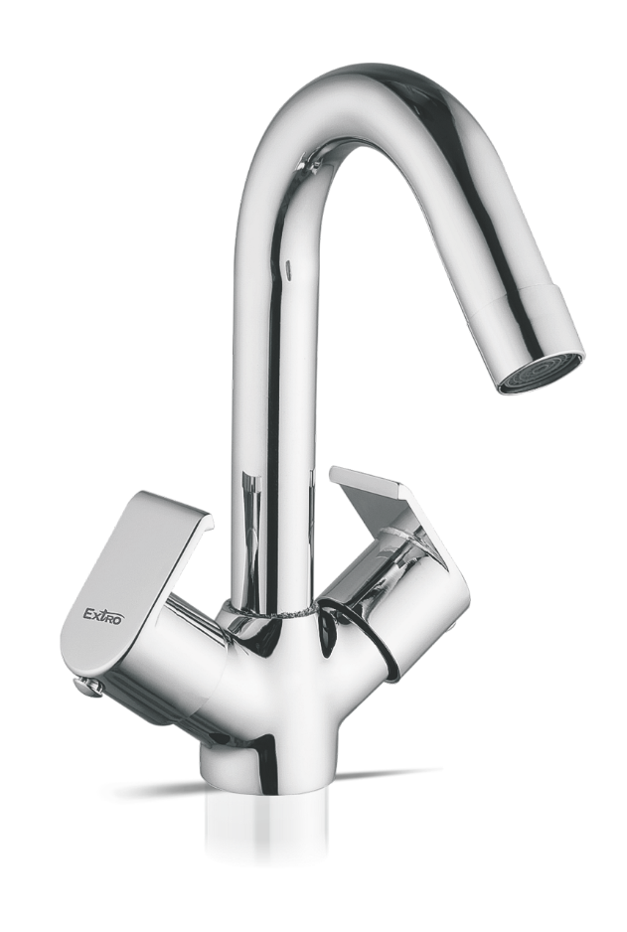

**Extro Wall Mixer with Overhead Shower Bend**

**Product Description:**  
A stylish wall-mounted wall mixer tap with an overhead bend pipe, designed for simultaneous or separate hot and cold water flow for shower and bath outlets.

**Key Features:**  
✅ Dual-control levers for hot and cold water mixing  
✅ Long overhead bend pipe for convenient shower connection  
✅ Integrated diverter for switching between spout and shower  
✅ Chrome-plated brass body for durability and rust resistance  
✅ Ideal for bathrooms with exposed plumbing setups

**Product Specifications:**  
• **Brand:** Extro  
• **Product Type:** Wall Mixer with L-Bend (Shower Connection)  
• **Material:** Brass  
• **Finish:** Chrome Plated  
• **Installation Type:** Wall Mounted  
• **Handle Type:** Dual Lever  
• **Connection Type:** 15mm (½”) BSP inlet  
• **Outlet Type:** Dual outlet – spout and overhead shower  
• **Control:** Diverter knob to alternate flow between shower and spout  
• **Application:** Bathroom shower + tub filler  
• **Warranty:** 5 Years Manufacturer Warranty

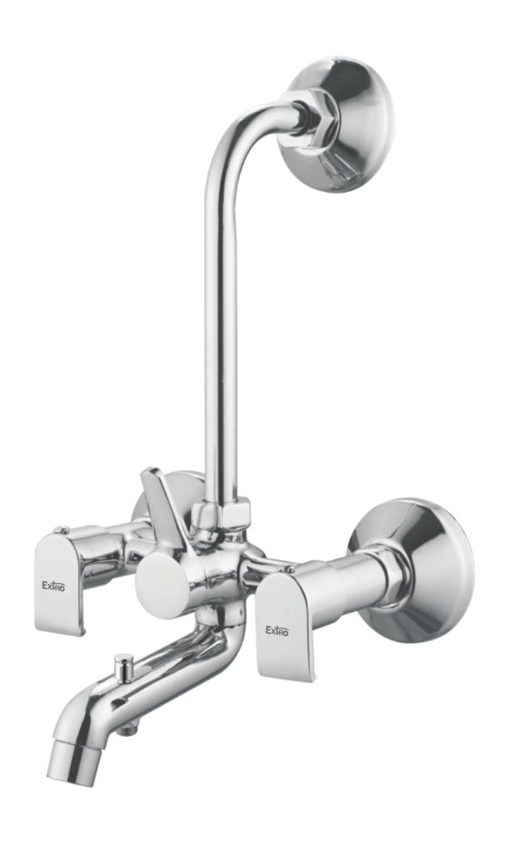

**Extro Wall Mixer with Crutch & Overhead Bend**

**Product Description:**  
Premium wall-mounted mixer faucet designed with a crutch handle and overhead L-bend for efficient switching between shower and tub functions, ideal for modern bathrooms.

**Key Features:**  
✅ Dual lever operation for hot & cold water control  
✅ Crutch-style knob for smooth diverter switching  
✅ Overhead bend pipe for direct shower attachment  
✅ Chrome-plated brass for long-term durability  
✅ Sleek modern design with ergonomic controls

**Product Specifications:**  
• **Brand:** Extro  
• **Product Type:** Wall Mixer with Crutch & Overhead Bend  
• **Material:** Brass  
• **Finish:** Chrome Plated  
• **Mounting Type:** Wall Mounted  
• **Handle Type:** Dual Lever + Central Diverter  
• **Inlet Connection Size:** 15mm (½”) BSP  
• **Outlet Type:** Spout + Overhead Shower Pipe  
• **Control Mechanism:** Quarter Turn Ceramic Disc  
• **Application Area:** Bathroom – Tub & Shower Mixer  
• **Warranty:** 5 Years Manufacturer Warranty

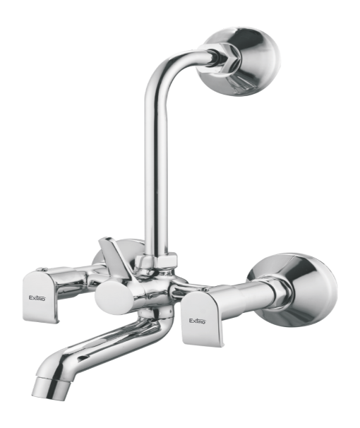

**Extro Swan Neck Tap with Dual Lever**

**Product Description:**  
Stylish deck-mounted swan neck tap with dual lever handles, delivering smooth flow control and aesthetic appeal for basins and countertops.

**Key Features:**  
✅ Dual lever handles for independent hot & cold control  
✅ High-arch swan neck for extended reach and clearance  
✅ Chrome finish enhances durability and visual appeal  
✅ Smooth quarter-turn operation for ease of use  
✅ Ideal for basins, counters, and modular bathrooms

**Product Specifications:**  
• **Brand:** Extro  
• **Product Type:** Swan Neck Basin Mixer  
• **Material:** Brass  
• **Finish:** Chrome Plated  
• **Mounting Type:** Deck Mounted  
• **Handle Type:** Dual Lever  
• **Neck Style:** Swan Neck (360° rotatable)  
• **Control Mechanism:** Quarter Turn Ceramic Disc  
• **Inlet Connection Size:** 15mm (½”) BSP  
• **Application Area:** Wash Basin / Counter Top  
• **Warranty:** 5 Years Manufacturer Warranty

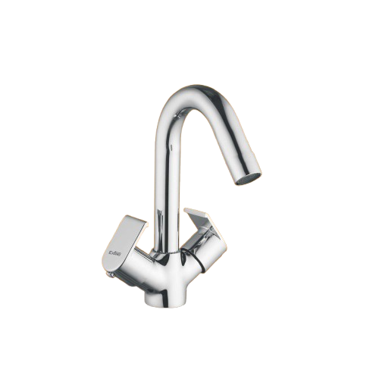

**Extro Angular Bib Cock**

**Product Description:**  
Wall-mounted chrome-plated bib cock with a contemporary angular design and single lever control, ideal for general water outlets.

**Key Features:**  
✅ Angular design with compact single lever  
✅ Chrome finish for anti-corrosion and durability  
✅ Wall-mounted for space-saving utility  
✅ Smooth quarter-turn operation mechanism  
✅ Ideal for utility areas, bathrooms & wash zones

**Product Specifications:**  
• **Brand:** Extro  
• **Product Type:** Angular Bib Cock  
• **Material:** Brass  
• **Finish:** Chrome Plated  
• **Mounting Type:** Wall Mounted  
• **Handle Type:** Single Lever  
• **Control Mechanism:** Quarter Turn Ceramic Cartridge  
• **Inlet Connection Size:** 15mm (½”) BSP  
• **Application Area:** Bathroom / Utility / Wash Area  
• **Warranty:** 5 Years Manufacturer Warranty

